Instructions to Set Up Laptop/Projector
in Pierce Auditorium
Step 1:
Enter the auditorium. Put the laptop on the stage and go to the back of the room to turn on the system
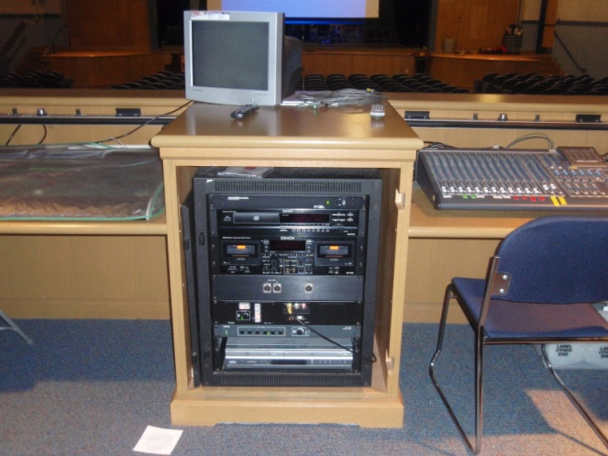
Step 2:
Turn on the system (top right of the system box)
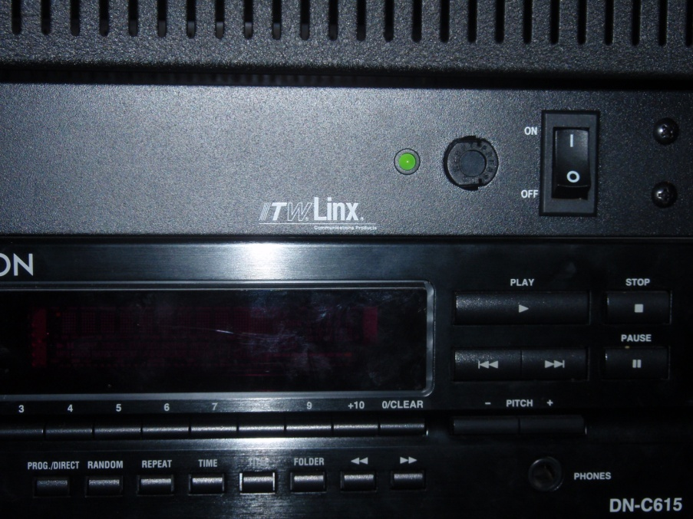

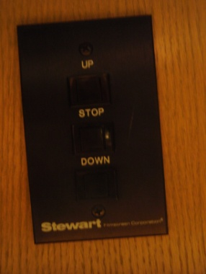
Step 3:
Pull down the projection screen by pushing the ‘Down’ button on the right hand side of the desk (black box – also has ‘Up’ and ‘Hold’ button)

Step 4:
To turn on the projector, hold down the ‘NO’ button. You should see a blue square on the projector screen once the project turns on (this might take a minute or so)
Then push ‘Lectern PC’ on the vertical set of buttons
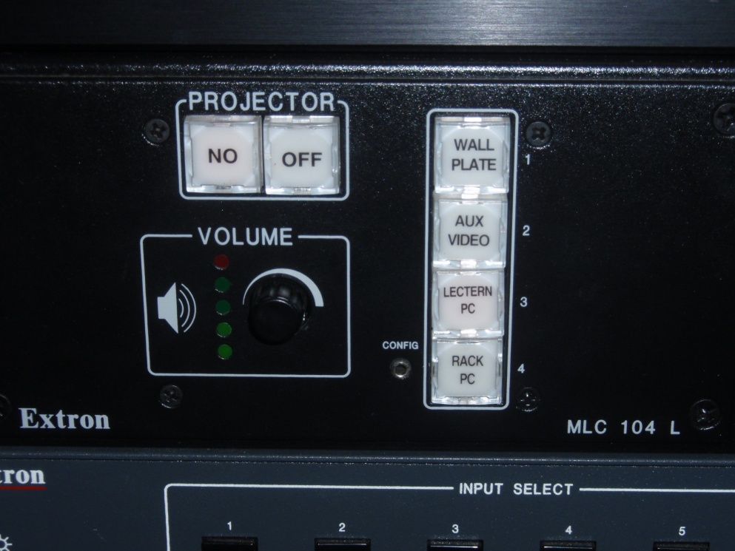

Step 5
Go back down to the stage. Plug in the computer’s power cord and plug in the blue cable (which is also connected to the computer)
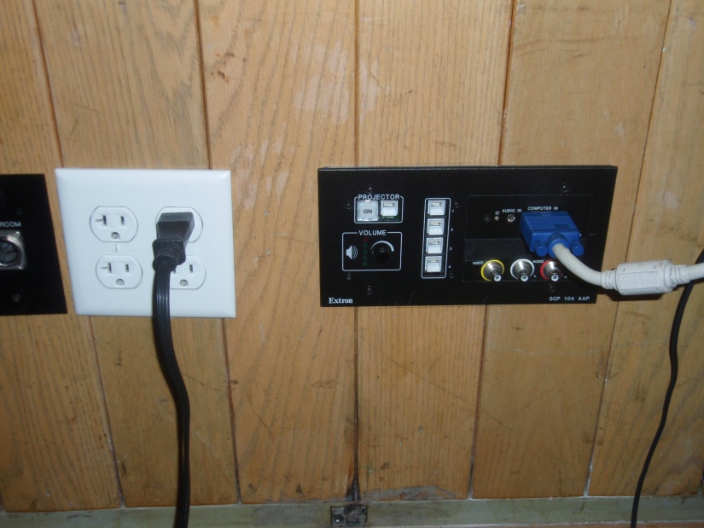

Step 6:
Turn the computer on.
Step 7:
Once the computer is fully turned on, you need to tell it to project. To do so, hold down the Fn button (bottom left) and the F8 button (top right) on the keyboard at the same time. The computer might be a little finicky so try this a few times if it doesn’t work the first time (if you get a black screen, just push Fn/F8 again and it’ll return you to the normal screen)
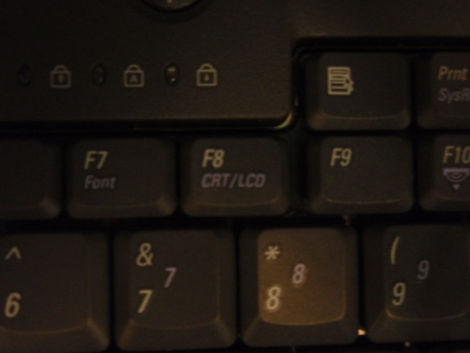
LMcCarthy 11-4-10

