Flip Video Camera User Guide

The Flip
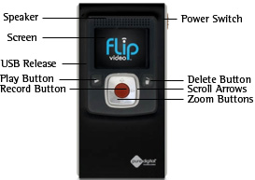
Getting Started
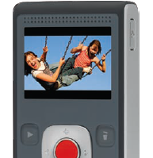
- Click on the Power Switch down on the side of camera to power on and off.
- Note: The Flip camera will shut itself off after couple of minutes of inactivity.

To Record
- Press the red Record Button. Green ready changes to a red circle on upper left of screen showing recording status.
- Press Record Button again to stop recording.
To Zoom
- While recording, press + and - buttons to zoom in and out.
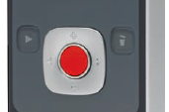

View Recorded Video
- When the green Ready light is showing on the screen, use the left and right Scroll Arrows on either side of the Record Button to scroll through saved clips.
- Press Play Button next to the Record Button to view recorded video.
- Use the + and – buttons to adjust the volume during play-back
Delete Video
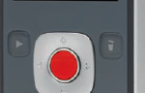
- Navigate to desired clip using Scroll Arrows and press Delete Button (trash can).

Tripod
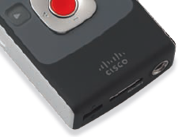
- Screw the tripod in at the bottom of the Flip. Adjust the legs accordingly.

Getting Video on your Computer (PC or Mac)
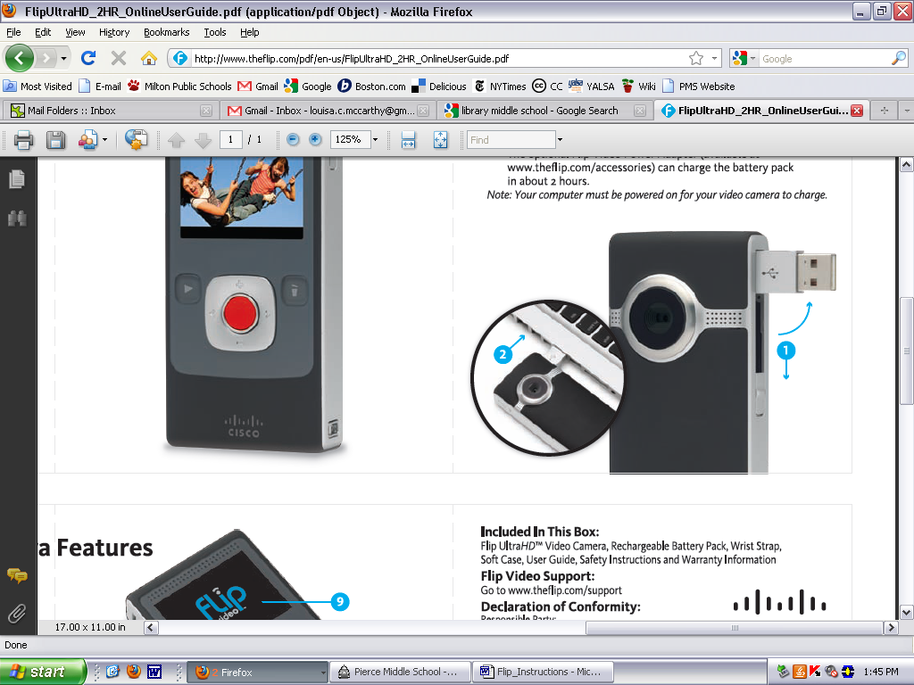
- Pull down USB Release, located on the opposite side of the Power Switch.
- Plug into USB port.
- The Flip Camera will appear in the Finder(Mac) or in My Computer(PC).
- Once the camera is plugged in, you will be prompted to open the videos using FlipShare. You can install Flipshare on your computer (it takes about 1 min.) and use that program to view your videos (see below)



