Instructions to Set Up Laptop/Projector
in Pierce Library

Everything will all be set/hooked up, all you need to do is turn on the computer and the projector. The instructions are below:

Step 1:
Turn the computer on. This is the power button on the top center of the keyboard. The computer should not require a password, but if it does, the user name is: laptop and the password is: password (all lower case).

Step 2:
Turn the projector on by pushing the green power button (this may take a few minutes to warm up)
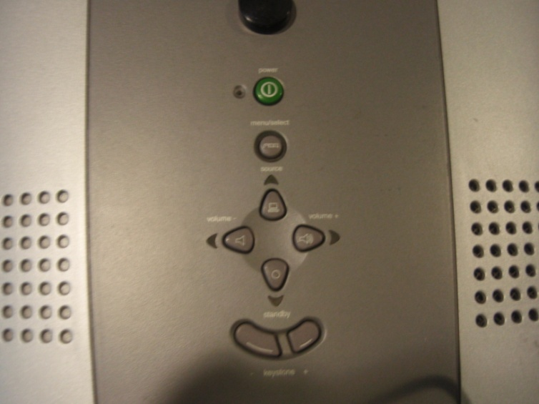

Step 3:
Once the computer is fully turned on, you need to tell it to project. To do so, hold down the Fn button (bottom left) and the F8 button (top right) on the keyboard at the same time. The computer might be a little finicky so try this a few times if it doesn’t work the first time (if you get a black screen, just push Fn/F8 again and it’ll return you to the normal screen)
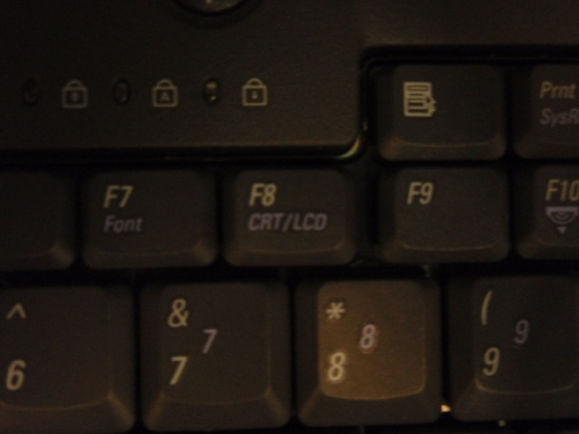

If all else fails…
If you are having too much trouble with the projector/laptop, use the Smartboard in the Computer lab. Simply turn on the ‘teacher’ computer (front left if you are looking at the Smartboard). Password is: 123.

